LAB EXPERIMENT 1

Create a Kanban Board to Visualize the Tasks.
- Create Columns for To Do, In-Progress and Done.
- Add Atleast 5 Sample Tasks
- Move the Tasks across the Columns to Simulate the Workflow

Aim
To create a Kanban board to visualize and manage tasks using three columns: To Do, In-Progress, and Done, and to simulate a workflow by moving at least five sample tasks across the columns.
Procedure
- Open a Kanban board tool such as Trello, Jira, or an online Kanban board application.
- Create a new board and name it Task Management Kanban Board.
- Create three columns: To Do, In-Progress, and Done.
- Add at least five sample tasks to the To Do column:
- Design the user interface.
- Develop the login page.
- Create the database.
- Test the application.
- Prepare project documentation.
- Move the Design the user interface task from To Do to In-Progress to indicate that work has started.
- Move the Develop the login page task to In-Progress to simulate another ongoing task.
- Move the Design the user interface task from In-Progress to Done after completing it.
- Move the Create the database task to Done to simulate successful completion.
- Keep the remaining tasks in their respective columns according to their progress.
- Review the board to verify that tasks are organized according to their current status.

Sample Kanban Board
To Do
Test the application
Prepare project documentation
In-Progress
Develop the login page
Done
Design the user interface
Create the database
Example of the board after simulating task movement.

OUTPUT:
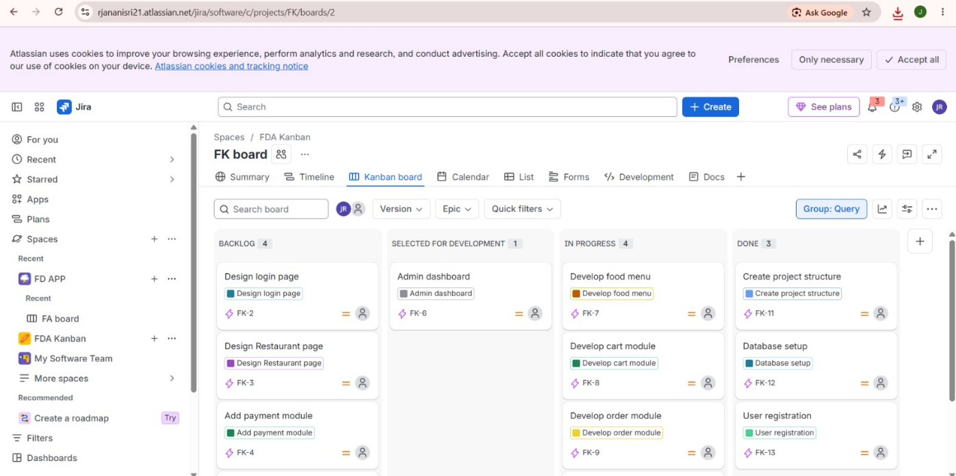
Result
Thus, a Kanban board was created with three columns: To Do, In-Progress, and Done. Five sample tasks were added and moved between the columns to simulate the workflow. The board helps visualize task progress, organize work efficiently, and identify pending and completed activities.

